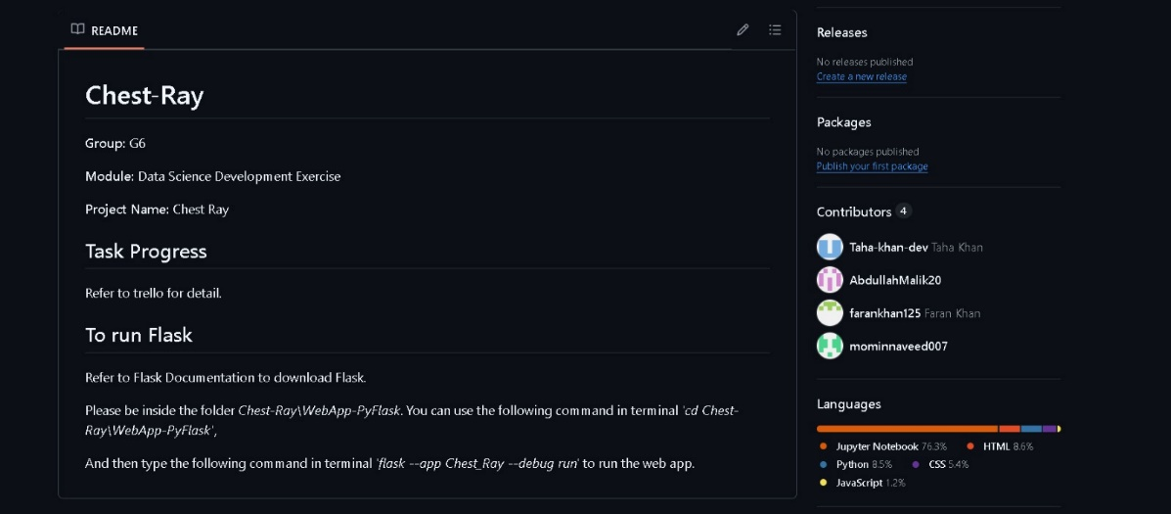**SCREENSHOT 1(EXPLAINED):**

This screenshot highlights our collaboration on Chest-Ray. We worked together to create Flask WebApp for a Data Science exercise. We developed tasks in Python HTML CSS and JavaScript. We used Trello for tracking task progress. Contributors made significant efforts to finalize the web application and ensure smooth functionality.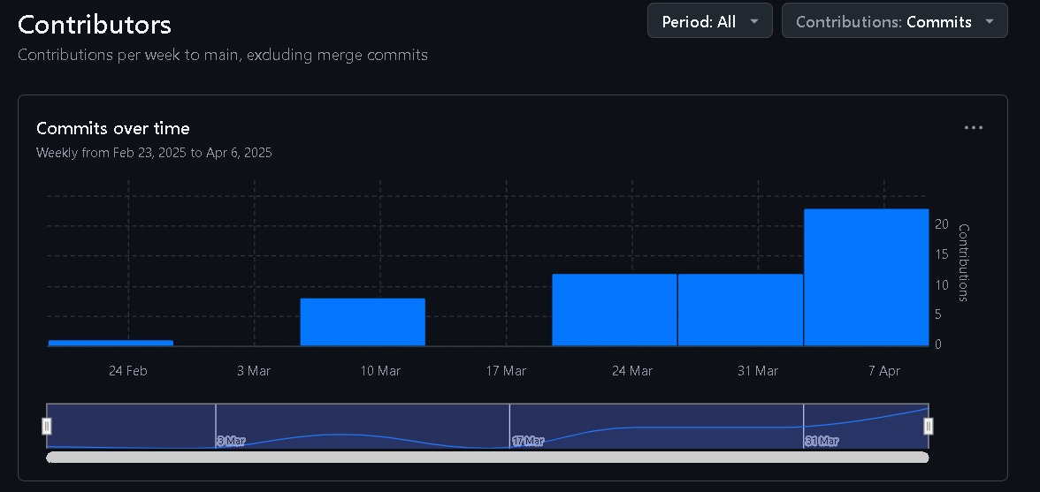

**SCREENSHOT 2(EXPLAINED):**

This screenshot highlights our team's consistent contributions throughout the project. We worked collaboratively to meet deadlines and complete tasks efficiently. The visual reflects how we divided responsibilities, made individual efforts, and strengthened overall teamwork to ensure the project's progress and success.

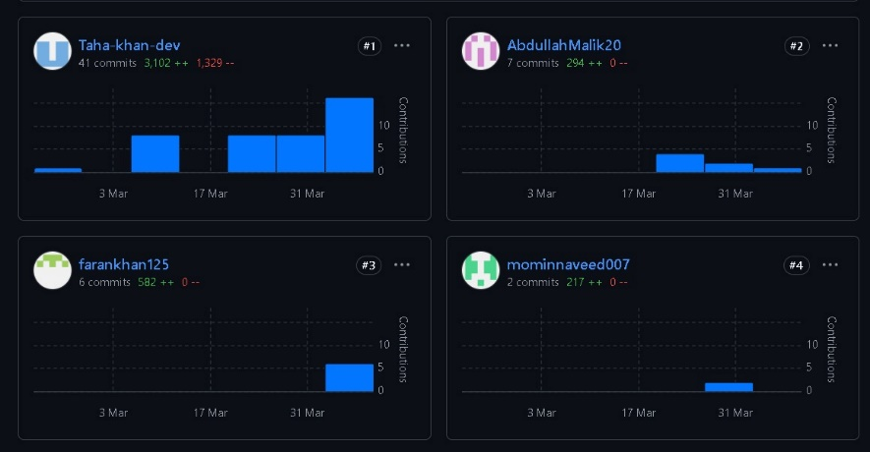

**SCREENSHOT 3(EXPLAINED):**

This screenshot shows our individual contributions to the project over time. We divided tasks, made individual efforts, and worked collaboratively to achieve goals. The contributions highlight teamwork, dedication, and consistent progress. We focused on completing assigned responsibilities and ensuring successful project development through combined efforts and effective collaboration.

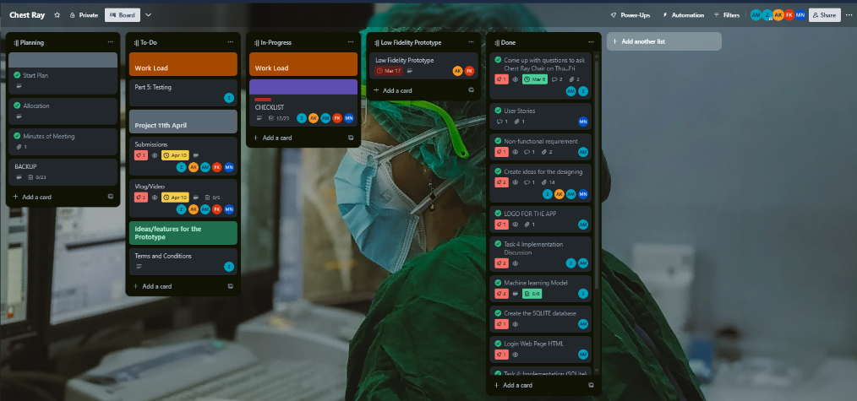

**SCREENSHOT 4(EXPLAINED):**

This screenshot shows our Trello board used for project management. We organized tasks into categories such as Planning, To-Do, In-Progress, and Done. We assigned responsibilities, tracked progress, and documented completed tasks. This tool ensured coordination, effective collaboration, and a clear overview of our project’s workflow and achievements.